Kathford International College of Engineering and Management
Balkumari, Lalitpur, Nepal

A
Project Proposal
On

Mero Diary: A Secure Web-Based Personal Journaling and Activity Recommendation Application

Submitted To
Department of Information Technology
Kathford International College of Engineering and Management

In partial fulfillment of the requirement for the Bachelor’s Degree in Computer
Science and Information Technology

Submitted By
Abhinav Singh Thapa (79010398)
Babita Subedi (79010404)
Khusi Dahal (79010410)

Submitted on: 2082/10/19

Abstract
Mero Diary is an online diary system which enables users to have an online journal of their day-to-day lives, personal activities, and health. It places emphasis on confidentiality and privacy, does password hashing using bcrypt, stateless JWT authentication, which provides a secure and scalable method of user login, and uses AES to encrypt diary entries, HTTPS to transmit secure data, and a strong per-user key management system. Users make entries in daily forms, as well as fill forms that measure different personal measures, and activities. These entries serve a hybrid recommendation engine which applies algorithm such as advanced rule-based algorithms or linear regression or random fit to propose optimum activities for well being of the individual.

i
Table of Contents
Abstract 2
1. Introduction 1
2. Problem Statement 1
3. Problem Objectives 2
4. Methodology 3
4.1. Requirement Identification 3
4.1.1.Study of Existing System/Literature Review 3
4.2. Requirement Analysis 5
4.2.1.Functional Requirements 5
4.2.2.Non-Functional Requirements 5
4.3. Feasibility Study 8
5. Timeline 9
6. Expected Output 9
References 10

Introduction
Personal journaling is significant in self-reflection, emotional life, and the structure of everyday living. As more and more people start using web-based technologies, online journaling has become a convenient way of how people can document their own experience, activities, and thoughts. Simultaneously, due to the sensitivity of the data of personal diaries, the requirements of strong security, privacy, and controlled access in such systems are noticed. The presented project introduces Mero Diary, which is a secure web-based journaling application, providing users with an opportunity to keep a digital record of their life, personal activities, and health on a daily basis. The system focuses on confidentiality by integrating secure means of authentication, encryption of data when storing diary entries, and safe transmission of data. Moreover, a hybrid recommendation system (rule based, linear and random forest algorithm) operates with user-recorded daily measures to propose appropriate activities and help a user create a healthier habit.

Problem Statement
Maintaining a personal diary in digital form is more convenient than offline methods due to ease of access, organization, and long-term storage. However, concerns about privacy, data misuse, and lack of trust in web-based applications discourage users from recording sensitive personal thoughts and well-being information online.
Additionally, simply recording daily entries does not fully support users in understanding or improving their routines and well-being. This project addresses this limitation by developing a secure journaling system that not only safeguards user data using robust security mechanisms but also analyzes journal inputs to generate concise, personalized activity recommendations aimed at supporting healthier daily habits and overall well-being.

Problem Objectives
- To provide a secure digital platform for users to conveniently record and store personal diary entries with strong privacy and data protection.
- To analyze user inputs to generate personalized activity recommendations that support healthier daily routines and overall well-being.
- To enable users to consistently track their habits and reflections in a safe, encrypted environment that builds trust and encourages regular journaling.

Methodology

Requirement Identification

Study of Existing System/Literature Review
The encryption and authentication methods are the main priorities of the secure digital journaling systems, but little attention is given to the personalized analytics of wellness and predictive suggestions [1], [7]. This gap is addressed by Mero Diary with its hybrid recommendation engine that combines rule-based logic, linear regression, and random forest algorithms. It has been found that AES-128 encryption is effective in the protection of secure web-based systems, where an average processing period of 0.84 seconds is attained when combined with HTTPS and client-side key management, which is suitable in the provision of journal entry protection [1].
The AES-128 performance optimization also contributes to real-time text encryption in the resource-constrained settings [5]. Commercial journaling apps like Day One offer end-to-end encryption, mood tracking, and AI-generated prompts on a few platforms, yet they are not predictive in terms of activity suggestions to the user based on metrics of user behavior [2]. On the same note, Penzu uses AES-256 zero-knowledge encryption to guarantee privacy without providing analytics-based insights to enhance well-being [4].
Current web security methods such as the integration of JWT authentication with the use of bcrypt password hashing algorithms offer stateless, tamper-resistant, and scalable user authentication, which allows access in a secure cross-device manner [3], [8]. These mechanisms are more effective than the traditional session-based authentication models and fit privacy-first application architecture.
Linear regression methods have been successfully used to make predictions regarding the outcome (health and wellness) of behavioral data, which has established a quantitative basis of the activity optimization systems [6]. Additionally, hybrid recommender systems that apply rule-based, regression and ensemble learning algorithms like random forests have been demonstrated to be more effective than single-model recommender in personalized wellness applications [7].
With the integration of established encryption and authentication methods and developed analytics and hybrid recommendation algorithms, Mero Diary complements the current digital diary platforms by providing potential, well-being insights based on data security.

Requirement Analysis

Functional Requirements
User Authentication & Security
- Users must register with email/password, hashed via bcrypt.
- Support secure login/logout using stateless JWT tokens.
- Automatically encrypt diary entries with AES using per-user keys before storage.
- Transmit all data over HTTPS only.
Daily Journaling
- Provide a daily form for text diary entries with timestamps.
- Capture user metrics like mood (scale 1-5), energy level, sleep hours, exercise, and reflections.
- Allow editing/deleting recent entries (within 24 hours).
- Auto-save drafts during entry.
Activity Recommendations
- Analyze daily metrics using rule-based logic (e.g., "low mood + poor sleep → suggest meditation").
- Apply linear regression to predict optimal activity levels from historical data.
- Generate 3-5 personalized activity suggestions daily.
- Support optional Random Forest for improved accuracy with more data.
Data Visualization
- Display mood/activity trends via simple charts (line/bar graphs).
- Show weekly/monthly summaries of key metrics.
- Allow filtering by date range.

Non-Functional Requirements
Availability: Loads quickly on normal internet, smooth for 1-5 user, 24/7 available
Security: Passwords hashed, diary encrypted and use of JWS sessions
Web-friendly: Works smoothly on phone browsers + laptops, responsive design
Reliable for demo: Doesn't crash during presentation, basic error messages
Private: Only you see your diary entries, simple delete button

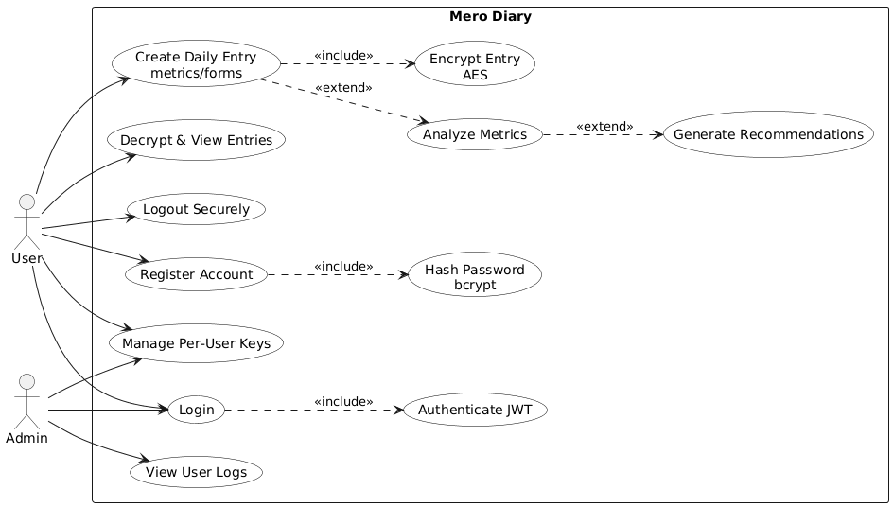

Figure 1: Use Case Diagram

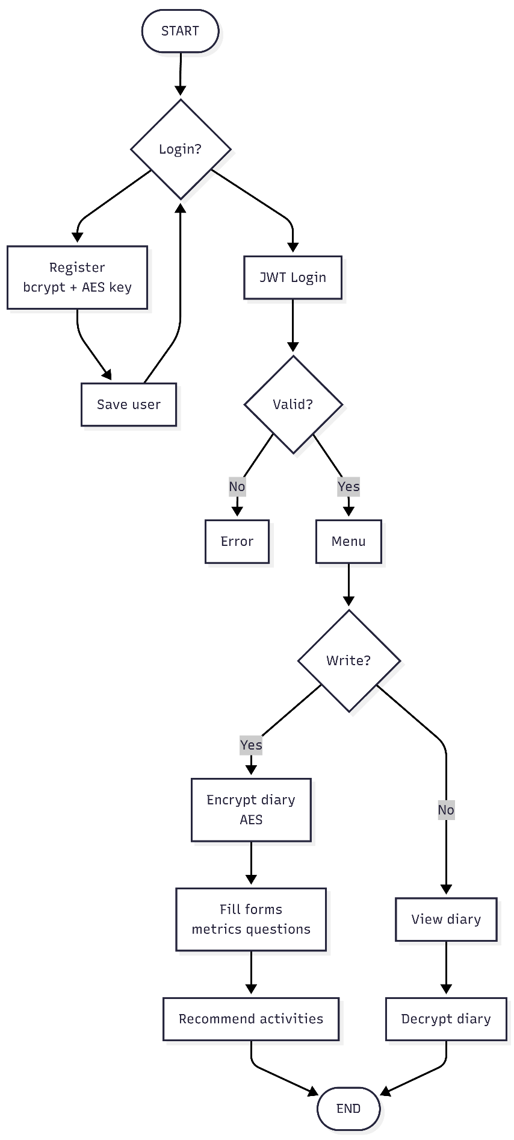
Figure 2: Flowchart

Feasibility Study
- Technical Feasibility
Mero Diary can be developed as a web app using ReactJS for the frontend, Node.js/Express for the backend, and Python for the recommendation engine. It uses standard web technologies and cloud services (Firebase) for database, authentication, and analytics, making development straightforward for a college project
- Operational Feasibility
The app is easy to use and suitable for all users. Daily forms and activity suggestions encourage consistent engagement, while automated encryption and recommendation processes reduce the need for manual intervention.
- Economic Feasibility
Development uses free or open-source tools (ReactJS, Node.js, Firebase/Supabase, Python), keeping costs low. No external hardware or software licenses are required, making it financially feasible for an academic project. The overall system development cost is minimal and affordable for academic purposes.

Timeline
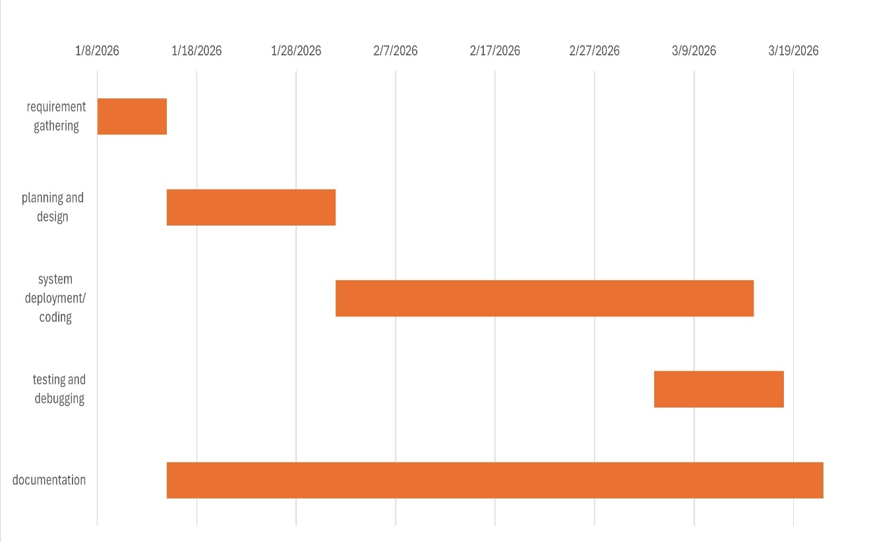
Figure 3: Gantt Chart

Expected Output
- A web-based journaling application that allows users to securely maintain daily diary entries.
- A backend system implementing secure authentication, encrypted diary storage, and user session management.
- A hybrid recommendation engine that provides personalized suggestions for activities or content based on user inputs.
- Visual insights and trends show user metrics over time, such as mood patterns or activity engagement.

References
[1] A. H. Nasrullah, “Secure web-based file encryption using AES-128,” Journal of Embedded Systems, Security and Intelligent Systems, vol. 6, no. 2, pp. 146–155, 2025.
[2] Day One Journal. [Online]. Available: https://dayoneapp.com. Accessed: Jan. 2026.
[3] J. Garcia and S. Kim, “JWT authentication in modern web applications,” IEEE Transactions on Information Forensics and Security, vol. 18, pp. 1234–1245, 2023.
[4] Penzu: Secure Online Diary. [Online]. Available: https://penzu.com. Accessed: Jan. 2026
[5] Z. Luo et al., “Optimization of AES-128 encryption algorithm,” Security and Communication Networks, vol. 2022, Art. no. 123456, 2022.
[6] R. Smith et al., “Linear regression for wellness prediction,” Journal of Biomedical Informatics, vol. 115, p. 103712, 2021.
[7] A. Kumar et al., “Hybrid recommender framework for wellness apps,” PeerJ Computer Science, vol. 10, p. e1880, 2024.
[8] M. Patel and H. Lee, “Bcrypt-JWT security in web applications,” Computers & Security, vol. 128, p. 103156, 2023.

